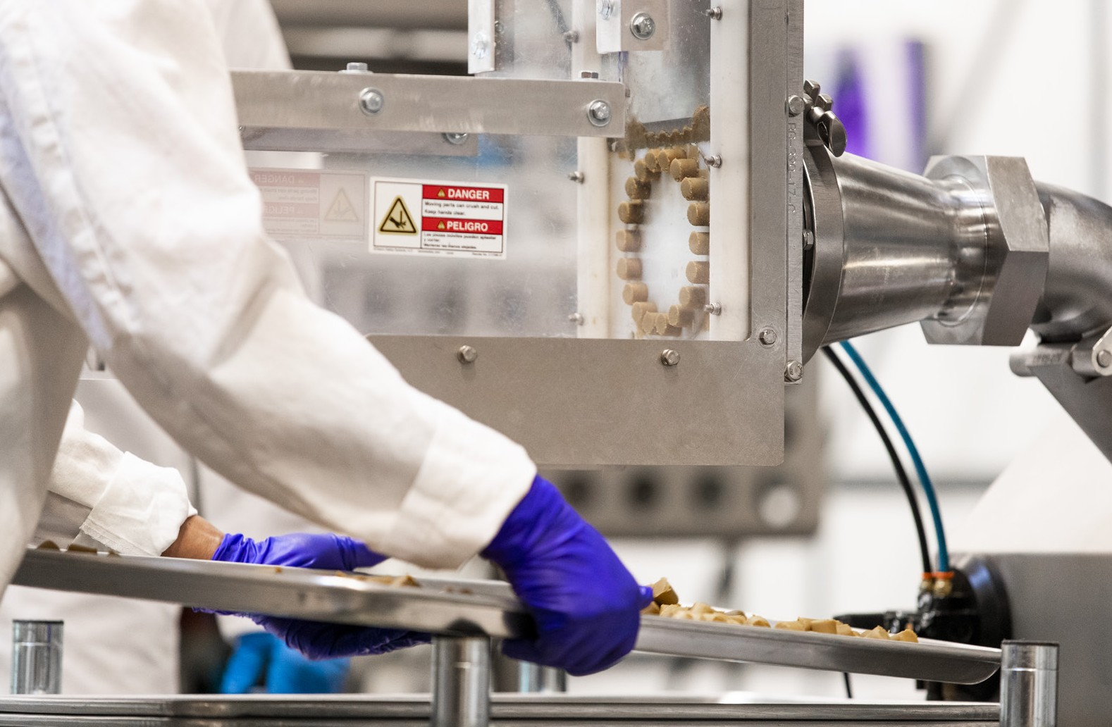Ways we help you win.

+ 30 years of experience
+ Product development/Formulation conversion/ Private Label
+ Strong supply chain management/ Volume purchasing
+ Highest quality product and ingredients
+ Contract manufacturing that maximizes efficiencies

High quality. Low drama.

+ USA manufacturing facility
+ Quality ingredients from trusted suppliers
+ Full service: develop, manufacture, package, ship
+ 100% focused on your success
+ Teamwork defines our approach

Certified awesome.

+ EPA
+ FDA
+ cGMP
+ USDA Organic
+ NASC
+ Health Canada
+ APHIS Canada

Capabilities.

+ Manufacture: Powders, Pellets, Soft Chews, Liquids, Extrusion, Roll Compaction, Granulation, Palatability verified by four-legged taste testers
+ Analytical: In-house cGMP Laboratory
+ Packaging: Solutions from 5g to 1000 kilograms, Design & containment to protection & communication

